Health Bot: AI-Powered Patient Education System live link =>live link

This project is divided into 10 parts

1 Ask the patient what topic or medical condition he wants to learns
Creating a langgraph function in which User can ask the Topic:
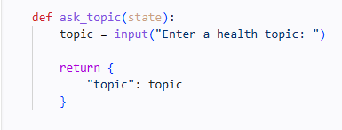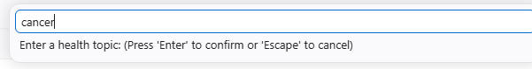

2 Using the Tavily Search Engine:
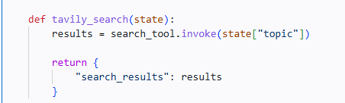

3 Summarize the Tavily Search Engine And Displaying it to the user: 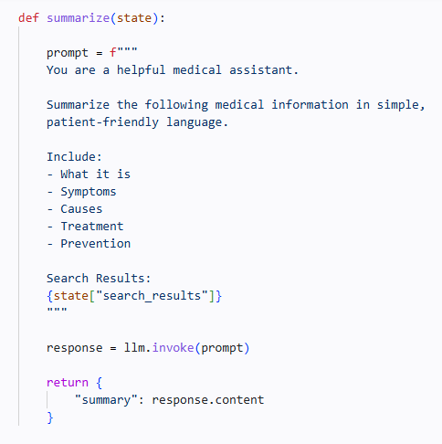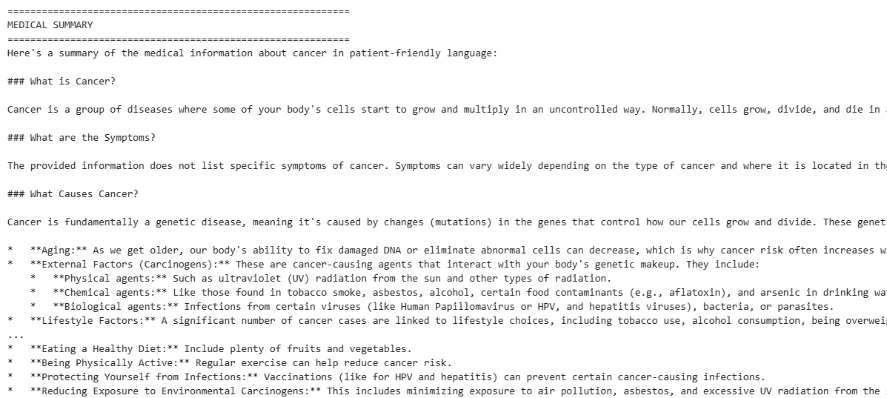
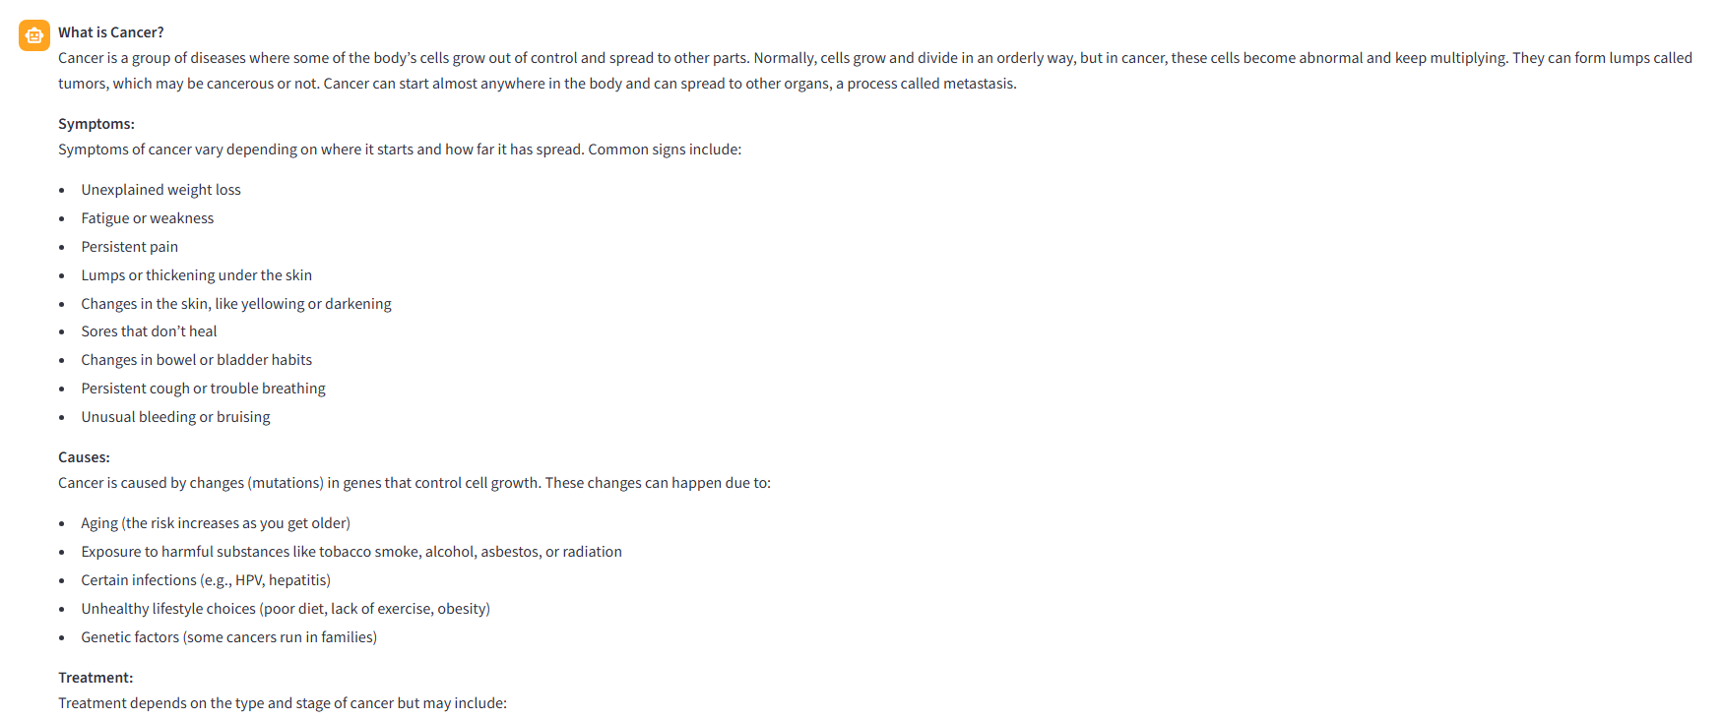

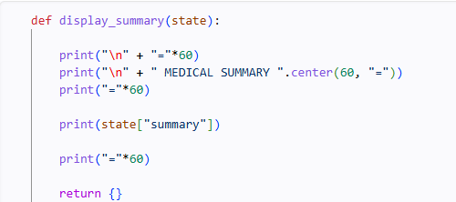

4 Prompt the Patient to indicate when they are ready for the test:
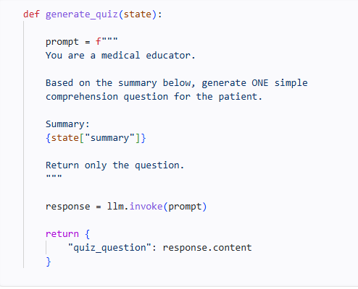
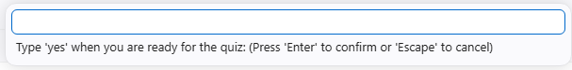

5 Generate a Single, relevant quiz question based on the provided information And Giving the quiz to the patient:
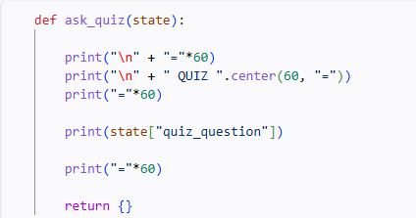




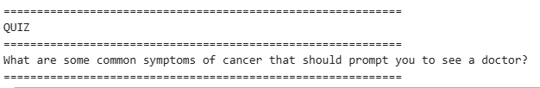

6 Allow patient to enter their Answer
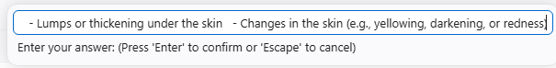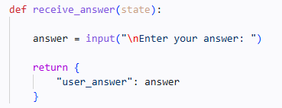

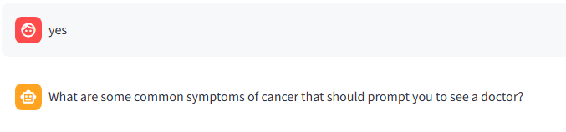

7 Evaluate the patient response, providing the grade and explanation and present the grade and explain to the patient: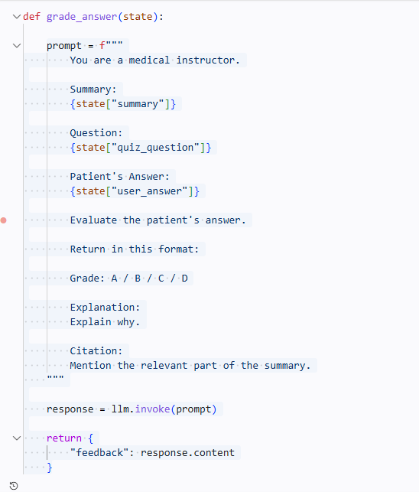t:

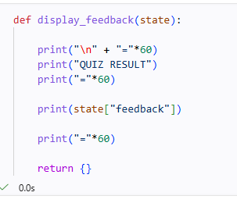
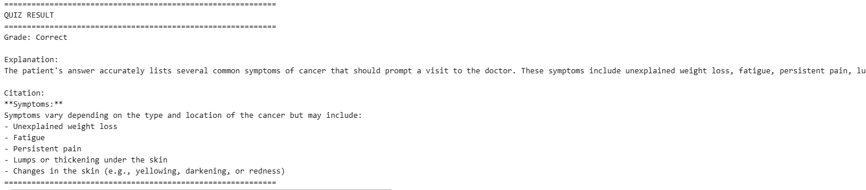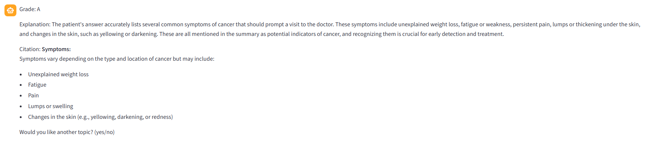

8 Ask if the Patient Would like to learn more topics or end the session:
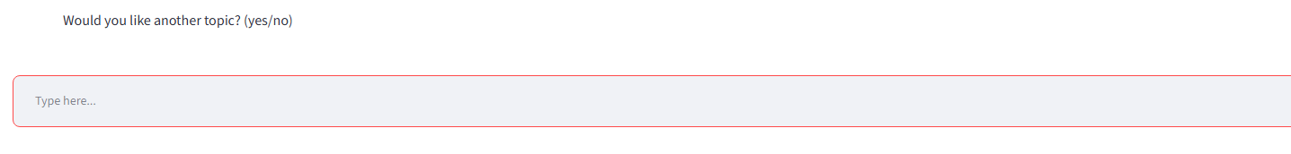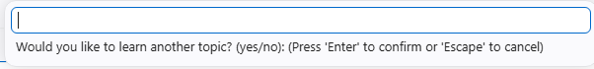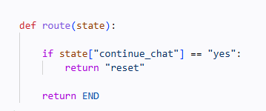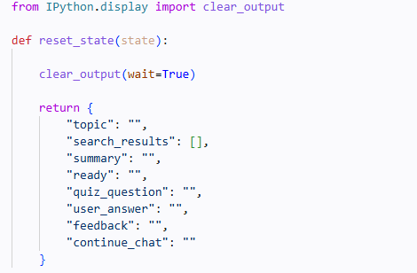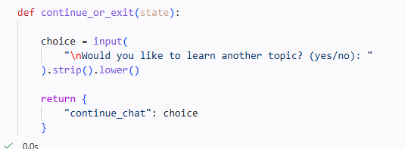

9 langgraph Workflow :
